Institute for Entrepreneurial Leadership
550 Broad Street, 15th floor, Newark, NJ 07102 | www.weareifel.org | @weareifel | 973.353.0611

Competitive Analysis Overview Template

Knowing what the competition is up to is the first step in identifying your competitive advantages, a key component of marketing and a driver of your sales approach. You will discuss the strengths and weaknesses of your primary competitors, determine your market sweet spot, and identify the attributes that form the foundation of your competitive advantage.

If you do not understand the competition and the competitive landscape, you will miss the mark completely on everything else. Looking at the competition also provides the basis for your pricing analysis. Starting with the competitive analysis really provides the foundation for the remaining elements of the business plan.

For example:

The chart below makes it easy to see how your product/service meets all of the needs of your primary audience and most importantly how you are different from your competitors.
Under the chart, It may be useful to write a statement like this "The following list summarizes the primary ways in which Company X will differentiate itself within the current competitive landscape:'' and follow with a bulleted list. A bulleted list also works well for articulating barriers to entry.
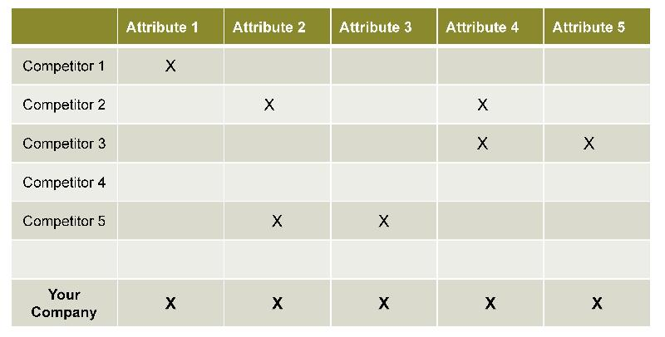

Competitive Analysis Overview Template

The most critical element of this section is a discussion about differentiation. If you can clearly articulate how you will be different, your plan will stand out from others. In this discussion, be sure to include:

- How your brand characteristics are unique
- Key attributes that separate your company from the competition
- Why consumers will select your product/service over the competition
- Opportunities to improve differentiation even more over time

 | Attribute 1 | Attribute 2 | Attribute 3 | Attribute 4 | Attribute 5 | Attribute 6
Competitor 1
Competitor 2
Competitor 3
Competitor 4
Competitor 5
Your Company | X | X | X | X | X | X

